RSC Box Calculator
[Custom Made - RSC 1024 (1).xlsx]

[RSC Custom Made Calculation.pdf]

Questions:
- Are there restrictions when inputing LxWxH for AF/BF/DW
- Types of paper:
Single wall - contains 3 layers of paper
- A Flute 5mm thickness - corrugation pattern
- B Flute 3mm thickness - corrugation pattern
Double Wall 8 mm thickness - contains 5 layers of paper
- DW = A Flute + B Flute
Blue join - 32 mm
- External dimension refers to the folded up size of the box. L x W x H
- Ref open size refers to the area of the box when it is unfolded
- Quality of paper M/T/K/W
- T - test liner
- Cheapest recycled
- K - virgin paper
- Aligned fibres, stronger
- W - white paper
- White colour paper, expensive
- M - Medium paper
- Usually used for corrugation as the middle layer
- Density of paper will affect the quality.
- Minimum liner meter - MOQ
- How to understand the paper quality notation?
- Example: AF T150/M150/T150 - this is the name of the type of paper

- T150 - the 150 is paper density of 150g/inch2
- Example: DW T150/M120/M150/M180/T150
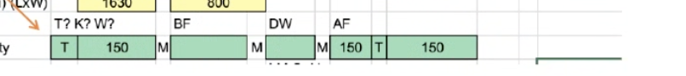
M = 150/120/180
- What is the filtering/selection logic to select the correct sheet board from the reference table based on user input in Page 4?
- What is the meaning of AF/BF/DW in paper weight calculation?
- DW = Double Wall?
- SW = Single wall?
- What are all possibilities?
- For each sheet borad there seems to be outer, medium and inner quality quantities, what do they mean?
- Meaning of Each quality M/T symbols?
- What is T/ K/ W ? And how will it affect the board quality calculation

- When will Ref Open SIze(mm) is used?
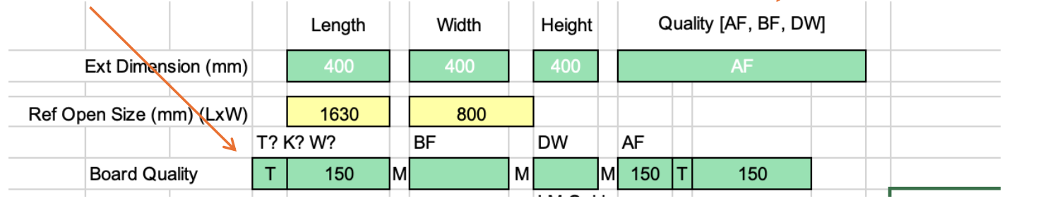
Ref open is for display purpose, no calculation needed, Ref open size is for reference when box is opened up to a full sheet (will reword it later)

- Glue joint size for AF = 35mm, BF = 32mm, DW = 38mm.
- No of Ups - number of boxes can be cut from a single pass of the sheet through the machine
- Varies from supplier, machine to machine
- Paper roll width calculation
- Ref A - + 2 And round up
- Ref B +4 and round up
- Ref C - S/W + 20mm DW +24mm
- Max roll width = 2.5m
- Min roll width = ?
- Roll width round up,
- 1100mm-1750mm to nearest 50mm
- 1800mm-2200mm to nearest 100mm
- Printing cost: Flexo/printing
- Ink cost = ?
- Glue cost= ?

Notes:
Estimated effort:
FE: 4 days
BE: 5 days
Test : 1 day

